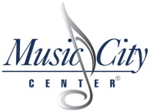

RFP Exhibit E
Commission Form

Compensation and Cost Data Worksheet for RFP 106-2021
Music City Center Audio-Visual Services
Offeror must enter commission percentages to be paid to the CCA for each of the categories included in their proposal :
 |  | Year 1 | Year 2 | Year 3 | Year 4 | Year 5
 | A.) Gross Equipment Rentals | 0.00% | 0.00% | 0.00% | 0.00% | 0.00%
 | B.) Gross Labor on Set-up/Teardowns | 0.00% | 0.00% | 0.00% | 0.00% | 0.00%
 | *Proposed percentages will be applied to "Gross Sales" defined as: total amount of all monies received including service charges, supplemental fees or monies charged by the contractor, its agents, subcontractors, or employees for all Audio Visual Services Sales excluding sales taxes or gratuities paid directly to contractor's employees and retained by the employees.

