EXHIBIT B
Official Bid (OB)

Instructions:
- Bids should be submitted by the time and date specified above.
- The vendor should provide the information below.

MAILING ADDRESS: | BID HAND DELIVER LOCATION:
Music City Center  700 Korean Veterans Blvd  Nashville, TN 37203 | Music City Center  600 Korean Veterans Blvd  Nashville, TN 37203

VENDOR INFORMATION
Company Name:
Name  (type or print): |  | Title:
Address:
City: |  | State: |  |  | ZIP Code:
Telephone Number: |  | Fax Number:
E-Mail Address:

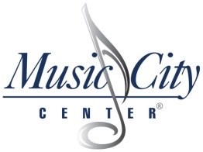

EXHIBIT B (cont.)
Official Bid Price Sheet

{Please fill in below}
Description Of Service | Lump Sum Fee
Reclaim Pump Repairs | $

NAME OF BIDDER:
EMAIL:
PHONE:
In submitting this bid, proposers represent: A) that the proposers has examined and carefully studied the Bidding Documents; and B) that all components and parts are accounted for and included to complete the product and specification requirements.
Print Name | Date
Authorized Signature | Date

Vendor Checklist

            - Read all pages of Invitation to Bid Document.
            - Read, sign, Notarize and return Exhibit A Affidavit.
            - Complete, and return Exhibit B Official Bid Form.
            - Complete, sign and return Exhibit B Official Bid Price Sheet.
            - One (1) original, three (3) copies, and one (1) electronic copy of the complete proposal response including any attachments, on a WINDOWS PC compatible CD or flash drive

[The remainder of this page is intentionally left blank.]

